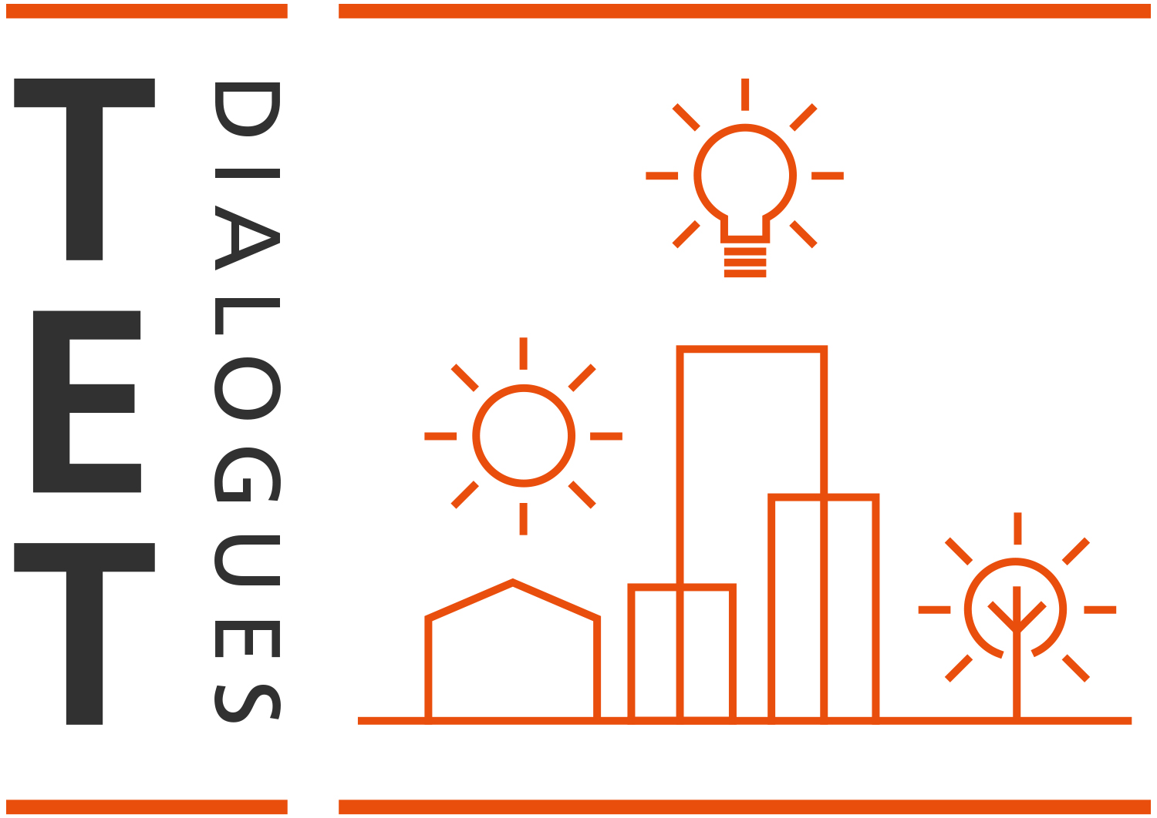
Thornton Education Trust – TET Dialogues
TET’s monthly informal webinars are an online space for professionals to share knowledge, learn from others and highlight good practice in engaging children and young people in urban design.
February 2022: ‘How to embed social value into practice through engaging future generations’
Engagement with children and young people is becoming an increasingly valued part of architectural and urban design practice, fuelled by a commitment to creating more equitable places for future generations. It is also welcomed by clients and public bodies.
Social value has rightly become a key issue for the built environment, and organisations are looking for new ways to add purpose to their work, while recognising a clear business case for doing so.
Our monthly TET Dialogue webinar highlighted examples of best practice from architects leading the way in embedding social value within their work, practice and ethos. Each shared how they’ve engaged with young people and children as a core element of these principles, how they’ve developed their own engagement programmes and connected with others, what the impact has been, and how this can create benefits for all. This event featured short presentations from expert speakers, with a chaired panel discussion and Q&A.
Speakers:
- Hilary Satchwell, Director, Tibbalds Planning and Urban Design, and Mayor of London’s Design Advocate (Chair)
- Claire Pollock, Partnerships Lead, Allford Hall Monaghan Morris
- Anna Davies, Director, David Miller Architects
- Mellis Haward, Director, Archio
- Shawn Adams, Co-Founder, POoR Collective

For more information, see speakers’ biographies and links at the end of this document.

Key questions for discussion:
- Broadly speaking, what do we understand as ‘social value’ within the context of architectural and urban design practice? Where does engagement with children and young people fit within this concept? What does ‘good practice’ look like?
- What are the practical starting points for embedding social value (in terms of engaging future generations) within your work and practice, or building your work and practice around such a commitment? What are the different opportunities, e.g. joining an external programme presented by an organisation like RIBA or Open-City, creating your own programme, setting up a mentoring or apprenticeship scheme, etc.? What are the relative pros and cons of each? How might such approaches differ between larger and smaller practices?
- What difference can engaging children and young people make, most importantly to their lives, learning and development, but also the evolution and delivery of an architectural project? How can we measure impact more effectively?
- For practitioners, and within the wider industry, how much do you think a commitment to embedding social value is perceived as providing a competitive advantage, especially in procurement processes?
- How can participation by architects in programmes engaging children and young people support employee recruitment, engagement and retention?

Summary:
Introduction
Hilary Satchwell
Hilary explained that social value is a key topic of the moment, partly because there is more widespread thinking that the quality of the physical environment alone is not enough. Equally, if not more, important is considering how places actually work, which involves economic, social and other factors that influence whether people will engage and whether they feel something is for them – a key factor for young people.
There are various ways of looking at how to involve young people in the creation of places: how we as built environment professionals, with young people, can make projects more responsive to their needs; and how young people’s involvement can also help them make sense of the changing world around them, and see where they can have influence. There is also a question of whether some practices or types of organizations are more open to thinking about the social value of projects, and so maybe more motivated to do this, and also about how a project or its outcomes might benefit public good. Importantly, social value and engagement work take a lot of time – it isn’t a quick fix; it is about having conversations where you can build trust and where people know that you will listen to their concerns.

Claire Pollock

Claire is the lead for the partnerships work of Allford Hall Monaghan Morris, a practice which has a staff of 500 and was founded 30 years ago. It has a well-established philanthropic corporate responsibility strategy and the partnerships work covers 4 main themes: humanitarian, community, climate action and education. Key aims include ensuring the profession is inclusive and diverse; generating an understanding among wider audiences of how different spaces are made and how they affect our lives; and supporting innovative education practice. The practice provides funding but also time in the form of staff volunteering and skills sharing, and likes to work with organizations and partners over a number of years
Claire highlighted various aspects of the practice’s work in education and with young people. Firstly, it uses its own buildings as a learning resource: for example, the White Collar Factory building in Old Street, London, has a running track on its roof, and this always generates a lot of interest among visiting groups. The practice prioritizes work with London state schools and with schools for which it has designed buildings, e.g. Westminster Academy. Another successful project has been an ‘open studio afternoon’ for more than 100 young people, who can meet an architect and directly ask all the questions they want answered about that profession, alongside visiting the model shop and doing activities such as drawing. In 2019 the practice set up a week-long summer school – consolidating its work experience offer – providing sessions on sustainability, digital design, architectural drawing and other topics, and then encouraging young people to work together to design their own buildings.
More recently activities have moved online, with packs of modelmaking materials being sent out and workshops delivered digitally – which has meant much wider engagement, sometimes across Europe as well as in the UK. The practice has also run activities such as model making and SketchUp sessions in its social value commitments as part of specific projects, along with other elements such as employability sessions, apprenticeships, work experience and work placements. A recent project was a summer school for 6- and 7-year-olds, involving, for example, sending the students materials and talking about how architects and interior designers decide what to use. Some of these projects often start out as principally being for enjoyment but their outcomes can also feed into more formalized processes.

Anna Davies

David Miller Architects (DMA) is a practice with about 24 staff, with offices in London and Liverpool. It has a strong commitment to social value that has developed over time. The practice strongly believes in a level playing field for all, and that if someone is passionate about design and building their background should not prevent them from being able to consider a career in architecture. A diverse team is critically important; as architects, we need to relate to the communities that we work in, and therefore opening up opportunities for all in order to attract the broadest talent pool has become a key aim. Another priority is opportunities for junior staff to develop important new skills; they can improve and practise their management skills by supervising work experience students, learning how to brief them clearly and setting deadlines. With the passing of the Social Value Act, clients have also asked the practice about the social value that it is going to deliver as part of publicly funded projects. Social value commitment can therefore be an important factor in the practice winning valuable projects.
In 2010/2011 the practice set out its CSR strategy, with its main target being to encourage new and diverse talent into the built environment. Pre-pandemic it provided about 16 placements per year, from which it has recruited staff. Once the pandemic struck, it realized it had to do something to still provide valuable experience to students who were interested in the construction industry, especially 16 to 18 year olds, probably one of the groups hardest hit by the pandemic. DMA therefore created a virtual platform, called the Virtual Design Academy, with resources and information about routes into the profession, but also online workshops with volunteer mentors, mimicking how the office worked in the real world. At the end of the week, the students had a portfolio of their design and were asked to do a 10-minute presentation to the office. The practice was extremely impressed by the students’ confidence and ideas.
DMA also provides apprenticeships, to offer different pathways into the practice, and in terms of external programmes it works with Placed, a Liverpool-based social enterprise that helps people of all ages and backgrounds engage in planning and design. Three of the DMA Liverpool team participate in their education academies. The practice also works directly with schools, on specific projects, but also in a more general way to e.g. provide career advice. The next phase of its responsible business journey is to become a B Corp, because this communicates on an international level that it acts as a responsible business in all aspects of its work, and ensures that responsible business becomes embedded in the company ethos.

Mellis Haward

Archio is a smaller practice that works in areas including community-led housing and cohousing, and with Community Land Trusts. Its ambition as a company is to create inclusive regeneration, and the practice is passionate about drawing on lived experience in its work. Mellis highlighted a number of the practice’s projects demonstrating this approach, and how as architects they seek to embolden young people in the area through the processes they use. For Archio, social value is about engaging local people at every stage and looking for opportunities to genuinely involve people in the community for their benefit. One project for a London Community Land Trust brought a workshop onto the site, and involved engaging directly with the neighbouring primary school. This was identified as an unusual opportunity for the children to understand that something is going to happen on that site, and for them to see it being built next to their playground over several years. By engaging the school, before there were any plans, and by building a long-term relationship, the children and their families have become advocates for the scheme, to the extent that many ended up hand-delivering the planning application to the local mayor.
The practice also believes that engaging with young people is about allowing them into the design process, making it transparent, interesting and purposeful, and enabling them to understand the timeline of development and where they are involved in it. Archio has also worked with the charity Young Advisors, which works with community leaders to help them better engage young people in community life, to bring positive interventions in addressing some adults’ concerns about young people’s use of public space. And in its teaching of university students studying architecture, the practice has encouraged students to design ways of starting a conversation, then meeting a community to test these ideas, which provided a very insightful commentary on architecture and again demonstrated that lived experience is so valuable to architects’ discourse. Archio advocates that 18- to 24-year-olds should be statutory consultees of any housing development in their area. They are the people who will be the most affected by climate change, and their fear about it should be heard more often by those who make decisions. They also ask the best questions.

Shawn Adams

POoR Collective is an acronym for ‘power out of restriction’ and three of its members have an architectural background; what brings the collective together is an acute awareness of the need for young voices to be platformed and for communities to be heard. Its mission is the development of communities through the elevation of young people. Over the last decade the amount of public funding for facilities such as youth centres has been severely cut, so POoR Collective seeks to provide opportunities for young people, by teaching them architectural design-related skills, but also enabling them to feel as if they have a stake in their local environment.
The organization works with local communities, local authorities and other organizations collaboratively to design something tangible, while giving young people the tools, skills and agency to make an impact in their local environment. POoR Collective has in some cases worked with vulnerable young people who are not in mainstream schools, or those with behavourial issues, often giving them their first introduction to any kind of creative industry. In this Shawn and his colleagues feel it is important to guide the young people and allow them to take the reins of design, as they believe you get some of the thoughtful and interesting designs when you give young people agency. The fact that the outputs have been designed by young people makes it easier for other young people to engage with them. POoR Collective has also worked with young people on showcasing their work to others, such as the People’s Pavilion project in Queen Elizabeth Olympic Park, for which an open voting system was set up, with the winning design receiving more than 1400 votes.

The presentations and audience Q&A discussion highlighted some common themes and lessons learned, including:
- In terms of working with young people ‘social value’ has a very wide definition and can encompass a great variety of activities, from work experience for students to just enabling young people in communities to see that they can influence the world around them
- Engaging with young people can deliver social value through allowing them to inform and shape the making of projects. That can really help confidence, self-esteem and their sense of being part of the community
- Young people may not know that they can impact and change the way spaces and places work, unless we talk to them about it. Young people’s involvement and role in a project should be elevated and not just seen as secondary, and no opportunity should be missed to go out and find young people to talk to about their ideas, needs and aspirations if they don’t join the conversation initially.

What next?
How do we take this forward this discussion? Capacity building is a key goal of TET. TET encourages practitioners to encourage others to join the monthly conversations, to connect people in their own networks, to share knowledge and resources, and to contribute their ideas about how they can make change happen. TET is a platform to signpost best practice and show the value of architecture education initiatives to stakeholders. For more information and to get involved with TET contact:
info@thorntoneducationtrust.org
https://www.thorntoneducationtrust.org/
Follow us on Twitter: @thorntoneducat1
Watch recordings of our events on our YouTube channel
Information on our speakers
Hilary Satchwell, Director, Tibbalds Planning and Urban Design, and Mayor of London’s Design Advocate (Chair)
Hilary is an architect, urban designer and masterplanner who works on housing and mixed-use projects that are about making good places, people and planning for good growth. She is a founder director of Tibbalds Planning and Urban Design working closely with communities. Using the design and planning process as a tool for delivery she brings together creative thinking and problem solving skills with the ability to unite people behind a shared vision.

Claire Pollock, Partnerships Lead, Allford Hall Monaghan Morris
Claire joined Allford Hall Monaghan Morris in 2012 bringing with her a wide range of experience in cultural administration, public engagement and grants management including from Arts Council England and the Commission for Architecture and the Built Environment. Since then, she has led on developing AHMM’s Partnerships and corporate responsibility work delivering the practice’s aim to take a creative innovative long-term approach. Claire’s role leading on Partnerships work works with staff from across AHMM to find best ways to use the practice’s collective financial and skills-based resources to support local, global and architectural communities. She oversees AHMM’s donations and corporate sponsorship and a volunteering programme. She also leads on social purpose engagement within projects including delivery, monitoring and reporting social value commitments. She is co-chair of the AHMM Partnerships group, identifying charities, educational institutions and not-for-profit organisations to support fitting within the group’s topics: ‘climate action’, ‘community’, ‘education’ and ‘humanitarian’.
https://www.ahmm.co.uk/practice/partnerships/
Twitter: @AHMMArchitects/
https://www.facebook.com/AHMMArchitects/

Anna Davies, Director, David Miller Architects
Anna joined DMA in 2009 and heads up their recently opened Liverpool office. An experienced architect, she works with both public and private sector clients creating uplifting spaces for living, learning and working. She is currently leading Claire House Children’s Hospice project, to design vital new facilities at a former monastery in Liverpool. Sharing DMA’s belief that the practice should be a force for good beyond the project brief, Anna has been instrumental in embedding social value creation in the practice working with young people. She is an ambassador for the social enterprise PLACED Academy, that works across the North West to engage and inspire young people to make better places and mentors through the SMF, Class of Your Own, Open City Accelerate and RIBA programmes. She also led the development of DMA’s Virtual Design Academy, an online week-long work experience for school age students that is designed to make architecture a more accessible profession.
https://www.david-miller.co.uk/social-values.php
Twitter: @DMA_Architects
Instagram: davidmillerarchitects

Mellis Haward, Director, Archio
Mellis is an architect and co-Director of Archio Architects, working at the forefront of community-led and affordable housing in the UK. Mellis is leading the design of pioneering affordable housing projects such as the first purpose-built ‘Community Land Trust’ housing in London, and co-housing schemes in Norwich and Sussex. Her expertise has been acknowledged through inclusion in the Architects’ Journal ‘40 under 40’ showcase of ‘the UK's most exciting emerging architectural talent’.
Mellis has a particular expertise in community-led design and participatory design processes. She was a Senior Teaching Fellow at UCL in 2020 running an architectural design unit focusing on participatory design and community engagement. Mellis speaks widely on methods of co-design for organisations including New London Architecture and Urban Design London. She brings experience of high-level research into housing having co-authored Transport for London’s report ‘Future of Living’ 2020.
https://www.archio.co.uk/
Twitter: @archio_ltd / @mellishaward
Instagram: archio_ltd

Shawn Adams, Co-Founder, POoR Collective
Shawn Adams is a writer, lecturer, and architectural designer. He has written for Wallpaper*, FRAME, the Architects’ Journal, ICON, Disegno, VICE and OnOffice. Shawn has also spoken on Sky News, The Guardian and at talks organized by the Royal College of Art. Having completed a master’s degree in Architecture from the Royal College of Art in 2020, his work ‘Plinths and Tapestry’ has featured in the Financial Times and The Guardian, and was the winner of the 2020 Architects’ Journal Postgraduate Student Prize. Previously, a New Architecture Writer, Shawn is an advocate for diversity and inclusion within the architecture industry and is a RIBAJ Rising Star. He is also the co-founder of POoR collective, a social enterprise that focuses on the development of communities through the elevation of young people.
http://shawn-adams.com
https://www.poorcollective.com/
Twitter and Instagram: @ poor_collective

