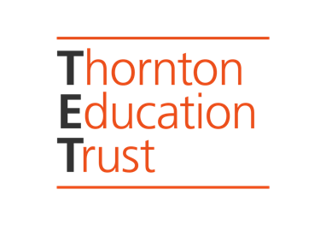
FOR IMMEDIATE RELEASE:

Thornton Education Trust’s Inspire Future Generations Awards 2022:
Today (Wednesday 16th November) the final shortlist is revealed

https://www.thorntoneducationtrust.org/ifg-awards-shortlist-2022
The shortlist is outstanding, and brings together many of the most enlightenedand engaged organisations and individuals who are setting the standard for others to follow in the sorely needed area of empowering future generations in shaping their built environment. As well as honouring these achievements, the awards allows us to harness the momentum building in this field of work.

Alongside the many brilliant existing and emerging not for profits pioneering this area highlighted in our inaugural 2021 Inspire Future Generation Awards, (https://www.thorntoneducationtrust.org/ifg-awards-winners-2021-by-category) this year several new categories have been added ‘Social Value Projects’ ‘ School Collaborations’ ‘Best Practice’ and ‘Best Local Authority’ highlighting enlightened private and public built environment sectors including a number of architectural practices creating impactful work in different ways (ZCD, Jan Kattein Architects, AHMM, Askew Cavanna Architects, Curl La Tourelle Head, WR-AP); Local government agencies (GLA, Meridian Water/Enfield Council and Greater Cambridge Planning Authority.

This year’s winners will be announced at The Building Centre on Monday 28th November, providing an unprecedented opportunity for this international network of architectural educators and enablers to come together.

Judge and TET Trustee Neil Pinder said: "Submissions this year showed how children and young people are increasingly being given agency in their own built environment. Many projects showed excellent engagement and working with the local community. Project outputs and outcomes have been of a very high standard, and the awards really highlight all of this vital work taking place."

2021 winners Matt + Fiona said: “The TET Awards are unique in their recognition of initiatives and programmes that aim to address some of the most pressing issues in the built environment industries right now: Namely increasing diversity in the professions and creating tangible ways for young people to genuinely have their say. Winning 'Best Organisation - Emerging' was a huge boost. It can feel an uphill struggle when you are constantly attempting to break new ground. It was therefore incredibly heartening and energising to receive this recognition, and very humbling to be in a room filled with so many peers who continually inspire us and encourage us to do better.”

Judges were Neil Pinder, recently awarded AJ100 Contribution to the Profession Award; Matt Bell, Heatherwick Studio, Stephanie Edwards, Urban Symbiotics, Rosie Parnell, Professor of Architecture and Pedagogy, University of Newcastle, Francesca Perry, Thinking City and Journalist and Hamza Shaikh, Winner of the IFG Individual of the Year Award 2021

Full shortlist here: https://www.thorntoneducationtrust.org/ifg-awards-shortlist-2022

About the awards: https://www.thorntoneducationtrust.org/ifg-awards-2022-announcement

Linkedin: https://www.linkedin.com/company/71700217/
Twitter: https://www.twitter.com/thorntoneducat1
Facebook: https://www.facebook.com/thorntoneducationtrust
#ifgawards

NOT FOR PUBLICATION:
Further information and photos available and invitations to Awards Evening on request from Jeni Hoskin on jenihoskin@thorntoneducationtrust.org/ 07305 865605.

